  - API Documentation
Version 2.0

Contents

- Overview
a. Prerequisites
b. Support
- Interface Specifications
a. API Request
b. API Response
c. API Exception
- Web API’s
1. Fetch Biometric Logs Data Between Dates
2. Fetch Biometric Logs Data After Maximum Attendance Log Index

Overview
- Prerequisites
Below are the following details required to access AmpleTrails API’s.
- eTime database.
This can be used in variety of Languages to access REST API’s like .Net, JAVA etc.

- Support
In case for any clarifications, Please get in touch with the API Support with Ampletrails team

Specifications
The API uses Http Requests to receive data and send responses in JSON format.

- API Request:
An API request lets you contact a server with API endpoints that you want to reach and perform some action. Those actions are HTTP methods.
- API Response:
An API response consists of the body, headers, and the status code.
- API Exception:
if there is an exception during the processing of the request then the application will send the response in the following

WEB APi’s
1. Fetch Biometric Logs Data Between Dates

Method: GET
http://abc.com/api/WebAPI/GetAttendanceBetweenDates

Example:
http://abc.com/api/WebAPI/GetAttendanceBetweenDates?AppKey=6432467912&StartDate=07/01/2020 9:12&EndDate=07/01/2020 20:02

Request JSON Object
- AppKey (String): To access the API method.
- StartDate (DateTime): from when the logs to be send.
- EndDate (DateTime): until when the logs to be send.

Response JSON data:
[
{
"DeviceLogId": "1",
"DeviceId": "23",
"UserId": "102",
"EmployeeCode": "102",
"EmployeeName": "Satya Ranjan Das",
"LogDate": "7/1/2020 9:04:09 AM",
"DownloadDate": "7/1/2020 9:04:20 AM",
"AttendanceDate": "01 Jul 2020",
"AttendanceTime": "09:04",
"Location": "PMKK Silchar",
"Direction": "",
"AttDirection": "",
"DeviceName": null,
"SerialNumber": "BJ2C190460658",
"IpAddress": "192.168.2.201",
"Status": "Success"
},
{
"DeviceLogId": "2",
"DeviceId": "21",
"UserId": "288",
"EmployeeCode": "288",
"EmployeeName": "Lalbiaksanga",
"LogDate": "7/1/2020 9:19:33 AM",
"DownloadDate": "7/1/2020 9:19:32 AM",
"AttendanceDate": "01 Jul 2020",
"AttendanceTime": "09:19",
"Location": "PMKK AIZWAL",
"Direction": "",
"AttDirection": "",
"DeviceName": null,
"SerialNumber": "BJ2C193060915",
"IpAddress": "192.168.101.11",
"Status": "Success"
}
]

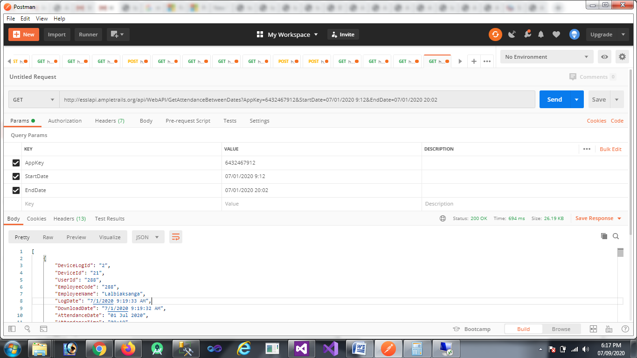

2. Fetch Biometric Logs Data After Maximum Attendance Log Index

Method: GET
http:/abc.com/api/WebAPI/GetAttendanceBetweenDates

Example:
http://abc.com/api/WebAPI/GetAttendanceAfterIndex?AppKey=6432467912&AttendanceMonth=7&AttendanceYear=2020&AttendanceAfterIndex=70

Request JSON Object
- AppKey (String): To access the API method.
- AttendanceMonth (String): Month for which records are to be fetched.
- AttendanceYear (String): Year for which records are to be fetched.
- AttendanceAfterIndex (String): Last attendance log index id after which records are to be fetched.

Response JSON data:
[
{
"DeviceLogId": "1",
"DeviceId": "23",
"UserId": "102",
"EmployeeCode": "102",
"EmployeeName": "Satya Ranjan Das",
"LogDate": "7/1/2020 9:04:09 AM",
"DownloadDate": "7/1/2020 9:04:20 AM",
"AttendanceDate": "01 Jul 2020",
"AttendanceTime": "09:04",
"Location": "PMKK Silchar",
"Direction": "",
"AttDirection": "",
"DeviceName": null,
"SerialNumber": "BJ2C190460658",
"IpAddress": "192.168.2.201",
"Status": "Success"
},
{
"DeviceLogId": "2",
"DeviceId": "21",
"UserId": "288",
"EmployeeCode": "288",
"EmployeeName": "Lalbiaksanga",
"LogDate": "7/1/2020 9:19:33 AM",
"DownloadDate": "7/1/2020 9:19:32 AM",
"AttendanceDate": "01 Jul 2020",
"AttendanceTime": "09:19",
"Location": "PMKK AIZWAL",
"Direction": "",
"AttDirection": "",
"DeviceName": null,
"SerialNumber": "BJ2C193060915",
"IpAddress": "192.168.101.11",
"Status": "Success"
}
]

