[Wednesday, May 11, 2022]

Proposal (RFP) for Time and Attendance cum Access control system

Proposal for Supply, Installation and Implementation of Biometric system.

AmpleTrails

Sub:-Proposal for Biometric Time and Attendance System.

Dear Sir,

This is with reference to our discussion. I am sending you Proposal for Supply, of system which can meet your requirement perfectly. We thank you for giving us the opportunity. We believe AmpleTrails Proposed Solution will meet your requirements perfectly.

Further to your mail please find enclosed a financial proposal for the same. We would be glad to provide any further details that you may require.

We assure you of our best services and attentions at all times and look forward to a lasting relationship with your organization.

Thanks & Regards

Shilpa Jain
Marketing Manager
+91-9315441053
+91-9034757673

Website: www.ampletrails.com
Email info@ampletrails.com

shilpa@ampletrails.com
www.ampletrails.com

Access Control System
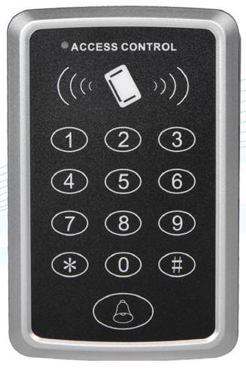
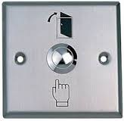

RFID Access Hardware & Software Commercials
Sr. No. | Particulars | Rate Per Unit (INR)
1  2  3  4  5  6  7 | Card Based access machine  Exit Switch  EM Lock  Power Supply  RFID Card  Installation charges  GST on total amount | 1500.00  550.00  2100.00  850.00  15.00  1500.00  @18% extra

Terms & Conditions:
- Payment: 100% advance through NEFT.
- Delivery: Hardware can be supplied & installed within 5-10 working days.
- Validity of Offer: 10 days from the date of Proposal.
- Power Point and wiring will be in customer Scope

Some of Our Prestigious Clients are
Hindustan Zinc Limited
JK Cement

Toshiba

Jaiprakash Associates Ltd.
Indian Railway
L&T Group

Haryana police

Softage Information Technology

