DAY WISE PUNCH TIME REPORT
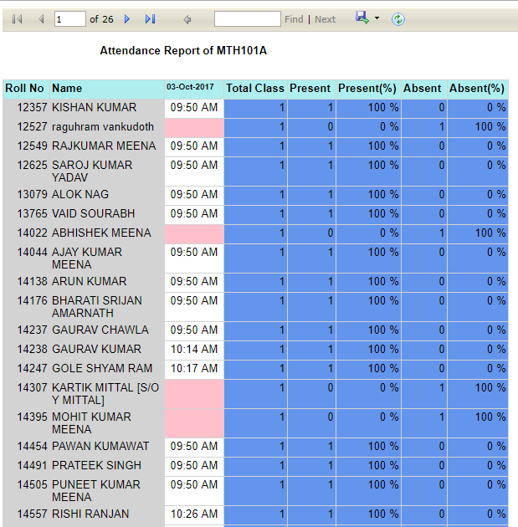

SEMESTER WISE ATTENDANCE REPORT
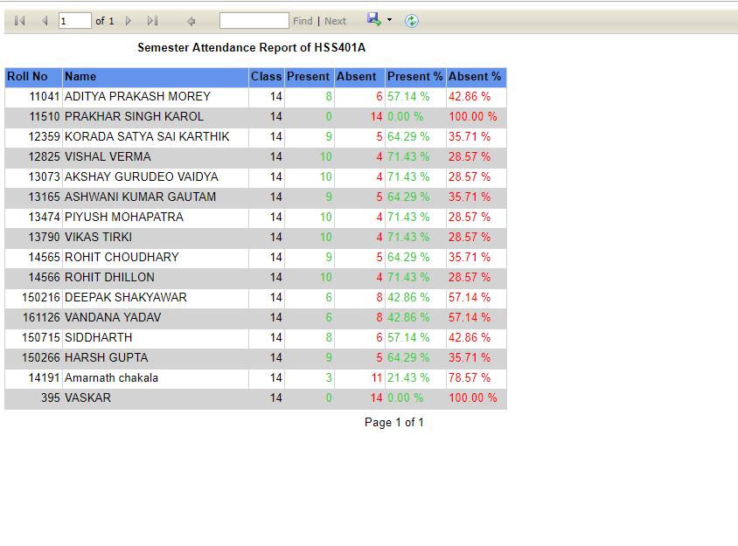

MONTHLY REPORT
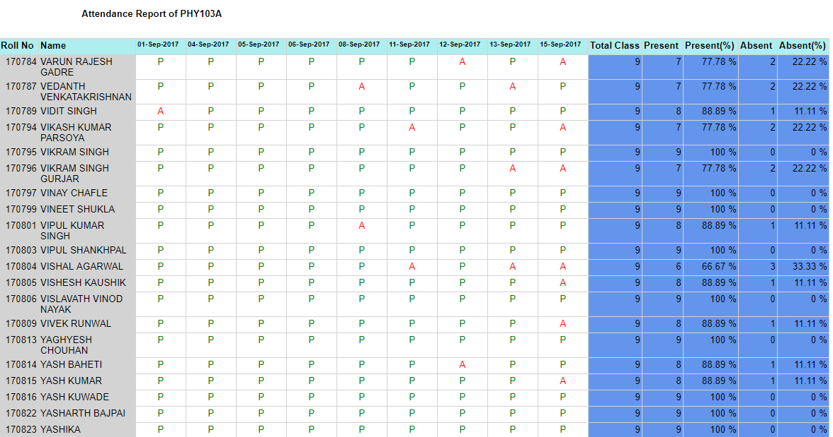

Consolidated course report
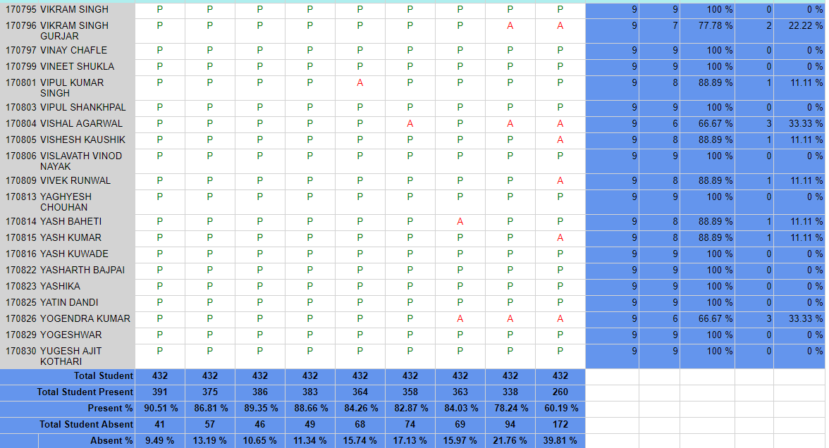

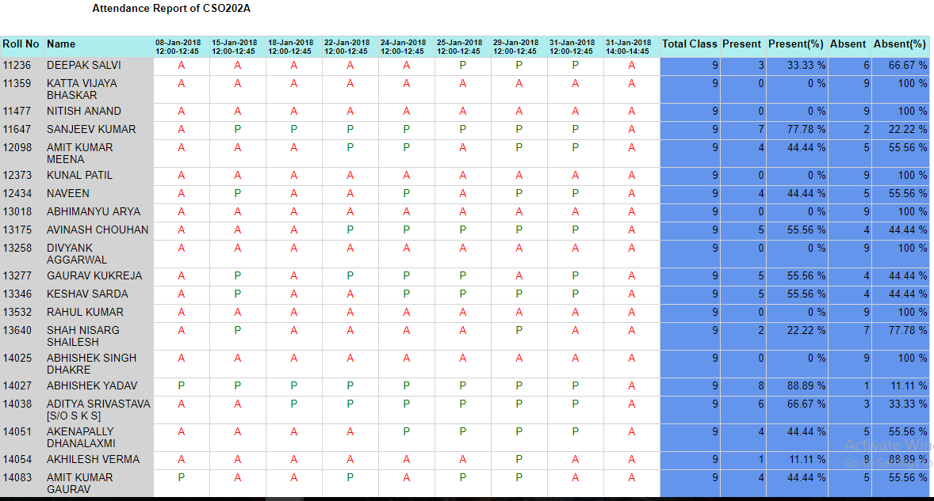
DayWise statistical report
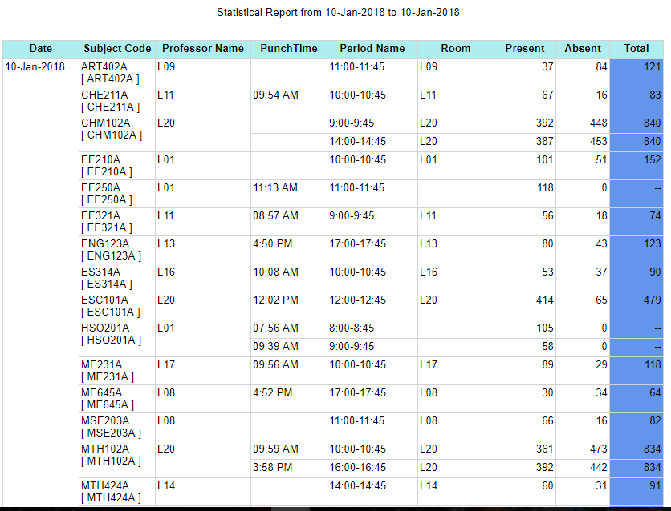

Student Attendance report
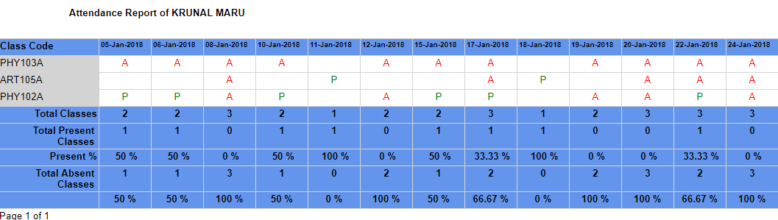

Head Office:-
Shop No. 5, 1st Floor, Kataria Market Sec 7,
Opp Arya Vidya Mandir, Gurgaon - 122001
Email:-info@ampletrails.com / www.ampletrails.com
Contact Us. +91-9315-4410-53, +91-9315441078

