OPERATING MANUAL- MODEL : BS-101

Refer the attached connection diagram to install Slave units in all classrooms of your premises. Part Id is mentioned on the sticker pasted on right side of each Slave Unit. For room no. 1 use Slave unit with Part ID – 1, for room no. 2 user slave unit with Part ID – 2 and likewise. After completion, power up the system and follow below mentioned procedure.
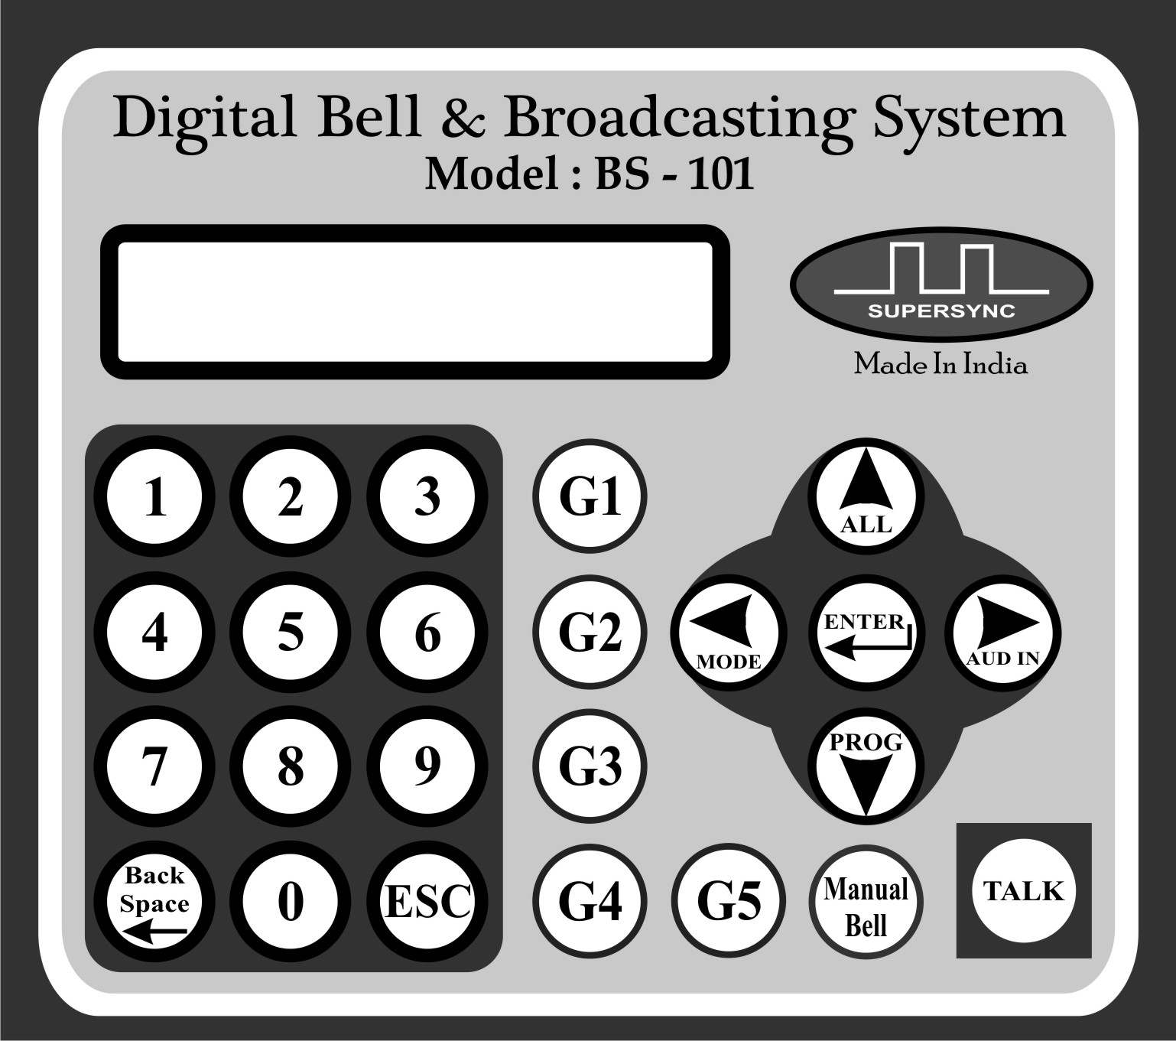

Above is the image of keypad on machine. All following features are explained using these keys.

Home Screen:

In standby state screen will display current time and calendar
01 May MON 10:10
SUMMER P01 11:00

in top row and Current running Mode - Active Program Number

-Next Bell Time in Second row. Functions can be initiated only

when system is at Home screen

Making General announcement: (All Call)

Press ALL (Top Arrow) key on Home screen to switch

machine to All Call Mode. Announcements made in this Mode
TALK KEY = PTT
0 KEY = HANDS FREE

will be audible to all rooms connected with this system.

Display will change as shown at right side.

To speak you can opt either to two options:

Talk Key = PTT means hold TALK key while speaking.

Voice will be transferred to all slave units only until Talk
SPEAK NOW

key is pressed. Screen will show Speak Now message

when system is ready to transmit voice to slave units.

0 Key = PTT, if you need to announce for a longer time

press 0 key and system will go under hands free mode. No need to hold Talk Key while speaking. Screen will show Speak Now message when system is ready to transmit voice to slave units.

Use ESC to come back to Home Screen.

Making group call:-

Keys G1 through G5 are programmed for making group calls.
1 GROUP SELECTED

On home screen press G1 for calling Group-1. Display will change

as shown at right side for 02 Sec and Press to talk screen will appear.
TALK KEY = PTT
0 KEY = HANDS FREE

Press to Talk function will work same as explained in ALL CALL

Description.

Likewise you can use G2,G3, G4 and G5.
SPEAK NOW

Use ESC key to roll back to Home Screen.

One to One calling to Single Room:-
14

Enter room number in two digits on home screen as shown.

Press Enter key, screen will change as shown at right side. User can

listen audio from selected room.
TALK KEY = PTT
0 KEY = HANDS FREE

Press to Talk function will work same as explained in ALL CALL

Description. Once you will press Talk Button, you voice will be
SPEAK NOW

transferred to all Slave units.

Press Esc key to exit.

Calling to Random Group of Rooms:-

System has a provision to call group of rooms selected randomly.
01 05 08 09 10
11 02

Enter room numbers that you wish to talk, Maximum of 10 rooms

can be entered as shown at right.

Press Talk Key (Do not press ENT key) directly, you can start
SPEAK NOW

Making announcements once you get Speak Now display.

Press Esc Key to exit.

Playing External Audio:-

System has the provision through which user can play audio Like any music, pre recorded message etc through PC, Laptop, Mobile, Tablet etc. using 3.5mm Jack cable.

Plug you device through 3.5mm jack cable with Master controller through 3.5 mm female jack at the back side of Master Unit.
EXTERNAL SOUND
ESC TO QUIT

Press AUD IN (Right Arrow Key) on Home screen.

Display will switch to the screen as shown on the right side.

Play the required music and press ESC to exit.

Manual Bell:-

To listen factory loaded 53 bell sound files press Manual Bell key
MANUAL MODE
FILE Srl. No. 01

on home screen.

Adjacent display will appear.

User Up arrow and Down arrow keys to change file numbers and press Enter to play.

Use ESC to roll back to home screen.

Mode:-

Automatic School Bell system can be programmed to run in three modes viz. Summer (SUM), Winter (WNT) and Examination (EXAM).

To switch between these functionalities press MODE key (Left Arrow key) on Home Screen. Adjacent menu will appear:
SELECT MODE
SUM WNT EXAM

Use right and left arrow keys to move cursor and press Enter to

Select the desired mode of operation.

PROGRAMMING
PROGRAMING MODE
It is a very easy to program system using full keypad and LCD display.
To enter in programming mode, press PROG key (Down arrow key) on
home screen. Display changes as shown at right side.

It stays for 02 Seconds and then main Menu screen is displayed as shown
SET DATE & TIME MAKE GROUPS
at right side. Cursor blinking on first character of top row. Using Up and
Down arrow keys user can switch between various menu option.

Exit programming:- Any time during programming press ESC key to exit
Programming and rolling back to home screen.

Setting Date & Time:-
01 MAY MON 10:10
SET DATE & TIME
- Press Enter key when cursor is on SET DATE & TIME Display will
change at shown at right side.
- Use UP and DOWN arrow keys to change the value and RIGHT-LEFT key to move cursor.
- Press Enter key to save the values.

Making Groups:-
SELECT GROUP
1 2 3 4 5
- Press enter key when cursor is on MAKE GROUP menu option.
- Display will change as shown at right side. Use Right & Left arrow
keys to move cursor to desired group no. and press enter key.
01 03 04 05 06
- Display will change as shown at right showing current rooms in the
group. Maximum 10 rooms entered to make one group.
- Edit existing room numbers or add new using number keys and
Backspace key to delete.
SELECT GROUP
1 2 3 4 5
- Press enter key to save, display will change as shown at right
- Make all groups in similar way. Press ESC to roll back to Main Menu.
SET DATE & TIME MAKE GROUPS

Bell Schedules:-
- Use Down Arrow key from adjacent screen to come at BELL
BELL SCHEDULES SUMMER WEEK DAYS
SCHEDULES menu.
- Use Enter key to enter into Bell Schedule menu.
- Adjucent Screen will appear. Where you will get Two Options:
PROG NEW SCHEDUL COPY OLD SCHEDUL
  - Prog New Schedule
  - Copy Old Schedule.
Through this menu, user can store 24 different time table schedules i.e P-01 to P-24.
Each schedule can be programmed with 50 bells for a day. So user can store 24 different schedules of 50 bells each covering all possible combinations of a year.
Through Prog New Schedule user can program a new time table or edit an existing time table in either of the program schedule i.e. P-01 to P-24.
Through Copy Old Schedule user can copy already programmed time table from one program schedule to another program schedule. For Example user has programmed a time table in schedule no. P-05 and he needs to program a new time table with just two modifications in already running program schedule P-05. So user can Copy P-05 to P-06 through this option and edit P-06 with only two modifications. No need to enter complete time table again in P-06.

- Prog New Schedule: Press Enter key to enter into this menu.
SELECT SCHEDULE
P-01
Adjucent screen will appear.
- User Up and Down arrow keys to select the program
schedule which you wish to program between P-01 to P-24 and press Enter.
Adjacent screen will appear.
P-01 TOTAL BELLS
50
- Machine will then ask to enter total bells required to ring in
24 hours. Maximum option of 50 bells is available. Use Number
Keys to change value and press Enter to move forward.
01 BELL TIME PRD
07:30 FILE 05
Adjacent screen will appear:
- Here user has to program exact bell time and file number of
1st bell of the day. Use Number keys to change values and Right-Left keys to move cursor to desired location.
- Total 53 Sound Files are factory loaded in Micro-SD card. List of these 53 sound files can be refered through Appendix-A enclosed with this operating manual. User can uploaded Total 99 such sound
files in MP3 format to this MicroSD card.
- Use Backspace key anytime during programming schedule to go to previous step . Use ‘Enter’ key to save and move to next screen. After programming last bell of the
SELECT SCHEDULE
P-01
day, press ‘Enter’ to return to the Select Schedule Screen.

Likewise user can program the entire day schedule. Please note the clock works in 24 Hours clock
Schedule, so for programming 01:00 PM enter 13:00 hours.
Follow exactly same procedure to program all 24 Program Schedules.
BELL SCHEDULES
SUMMER WEEK DAYS
Use “ESC” key on adjacent screen to roll back to main menu.

Summer Week Days:-
- Use DOWN arrow key to bring cursor on Summer Week Days option.
- There are basically three modes of allotting various program schedules to various weekdays.
1. Summer Week Days.
2. Winter Week Days.
3. Prog Exam Days.
Following is the process of programming Summer Weekdays. Likewise user can program weekdays for remaining two modes.
SUMMER WEEK DAYS
M –T –W –T –F –S –SUN
- Summer Week Days: Use ENTER key to on above menu to enter.
Adjacent screen will appear:
- The screen shows various week days of a week. Use Left & Right
SUMMER WEEK DAYS
THU P??
key to Move cursor to desired day of the week and press Enter to
select. Adjacent screen will appear.
- Suppose I’ve saved my schedule in P15 and want to run the same
time table from Mon to Wednesday. So I’ll select P15 in all week
days from Mon to Wed. Use number keys to enter program
schedule.
SUMMER WEEK DAYS
WED P15
SUMMER WEEK DAYS
TUE P15
SUMMER WEEK DAYS
MON P15

- For Thursday to Saturday suppose I’ve a separate time table which I’ve saved in P10. So I’ll select P10 for Thu to Sat and Sunday as Holiday. For Holiday select P00.
SUMMER WEEK DAYS
THU P10
SUMMER WEEK DAYS
SAT P10
SUMMER WEEK DAYS
FRI P10

SUMMER WEEK DAYS
SUN P00

BELL SCHEDULES
SUMMER WEEK DAYS
To exit use ‘ESC’ key, following screen will appear.
Like wise user can program Winter Mode and Exam Mode.

Calendar Holidays:-
CALENDAR HOLIDAY
MONTHLY DAYS

- Press Enter to select this option. Here user can program maximum
10 calendar Holidays for every month of year. So in total 120
Holidays can be programmed in a year except weekly holidays like Sunday.
- Adjacent screen will appear. Select YES if we have calendar holidays
CALENDAR HOLIDAY
YES NO

or NO to exit.
- On pressing YES, adjacent screen will appear. Select Month using
SELECT MONTH
AUG

UP and Down arrow keys in which user needs to store Holidays.
Either to following screen may appear:

01 10 15

?? ?? ?? ?? ??
?? ?? ?? ?? ??

- We assume we have 5 Holidays in AUG month as in dates 02, 09, 15, 24, 30. Use Number keys
02 09 15 24 30
?? ?? ?? ?? ??

to enter dates and shown in adjacent screen and press Enter to save.
- Repeated entries will automatically be deleted. Likewise user can
program 10 holidays for every month.
- To Exit press ‘ESC’ key, you will reach to next menu.
CALENDAR HOLIDAY
MONTHLY DAYS

Monthly Days:-
- Press Enter to select the menu option. Here user can program maximum 2 special schedules or Holiday for maximum 2 days of month. For example we assume that school has holiday on second Saturday of every month and a special schedule saved in P-05 on every fourth Saturday. Follow following steps to program the same:
MONTHLY DAYS
NIL

- Adjacent screen will appear after select this menu.
- If you don’t have any Monthly days option then select NIL and
come press enter to come out of menu.
- As per our above example we have two special schedules. So use UP arrow key and select 2 in place of NIL.
MONTHLY DAYS
2

- Following screen will appear:
1 MONTHLY DAYS
1st MON P-??

- As per our example we have to program second Saturday as Holiday. So use UP key to select 2nd than Right key to move cursor to Day and select SAT in place of MON, than again right key to move cursor to program schedule P-??. Here in place of question marks use UP and Down key to make it P-00. Press Enter to Save and more to second step.
1 MONTHLY DAYS
2nd SAT P-00

- Next we have to program P-05 to run on every fourth Saturday. Follow same procedure as mentioned in above point to make fourth Saturday run with P-05.
2 MONTHLY DAYS
4th SAT P-05

- Press Enter to save and exit to main menu.
MONTHLY DATES

Monthly Dates:-
- Like Monthly days, in Monthly Dates menu user can program maximum 2 dates of month with holiday or with some special schedule. For Example we assume school has holiday on Last working day of every Month and special schedule saved in P-20 to run on 15th date of every month.
MONTHLY DATES
2

1 MONTHLY DATES
15 P-20

1 MONTHLY DATES
LAST DATE P-00

- Press Enter to Save and Exit.

---------------------------------------------------------------------------------------------------------------------------------------

Caution:
- Follow Connection Diagram before installation.
- One wrong connection may damage complete system.
- Never connect AC main supply or DC supply on Audio IN or Out terminal of Master unit or any slave unit.
- Maintain a constant supply voltage at 220V 50Hz AC.
- Avoid any cable to get routed near to high tension power line or any transformer or any device generating magnetic field. Installation in these conditions may lead to distortion in audio quality,
- Keep away from direct sunlight and water.
- Keep power supply in ventilated area.
- Keep away from pointed needles or pointed edges, this may damage LCD display.

