

API to Get Commands For Device
[GET]
Example:
http://localhost:6239/api/CommandsForDevice/GetCommands?ApiKey=352474294&CompanyID=ATC&DeviceSerial=1234100
Parameters:
http://localhost:6239/api/CommandsForDevice/GetCommands?
ApiKey=352474294
CompanyID=ATC
DeviceSerial=1234100

Response:
{
"CommandID": "324",
"CommandType": "OpenDoorTemporary",
"CommandDuration": "10",
"DurationType_Minute_Seconds": "Seconds",
"CurrentDateTime": "03-19-2024 17:31:36",
"Status": "Success"
}

Note:

Response of "DurationType_Minute_Seconds": "Seconds" can be Minute or Seconds based on that we need to decide for how long the relay should be controlled.

Response of "Status": "Success" can be Success or Failed. That can be used to identify whether we are allowed not to use the API.

Postman:
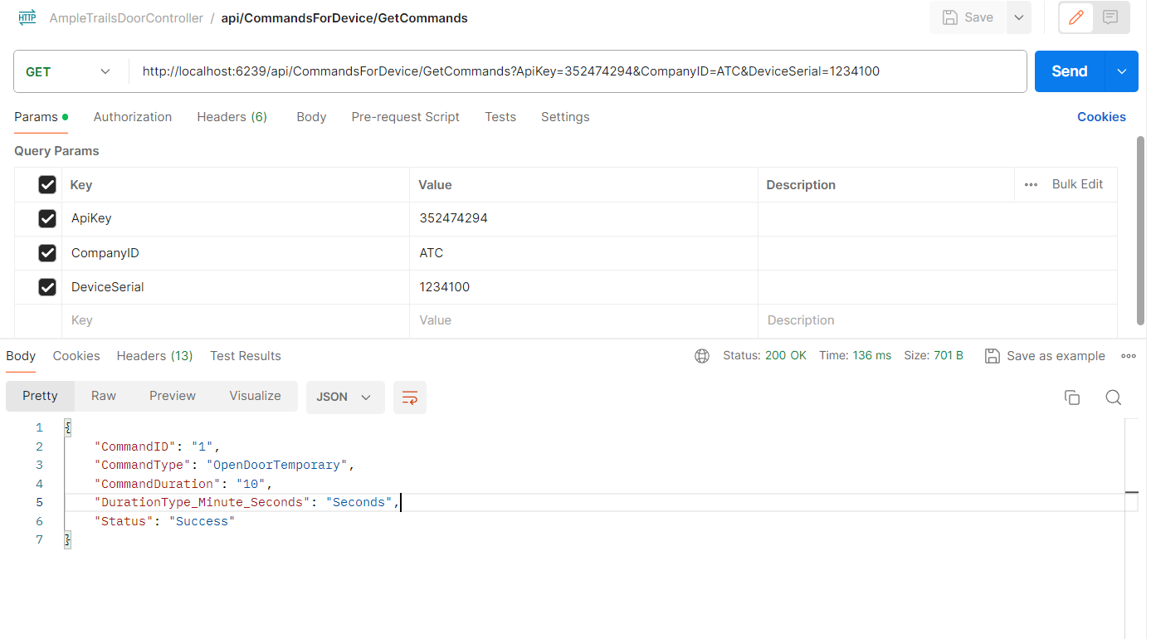
API To Save Events Handled by Controller
[POST]
Example:
http://localhost:6239/api/DeviceEventsHandled/SaveLog?ApiKey=352474294&CompanyID=ATC&DeviceSerial=1234100&EventType=OpenDoorTemporary&EventDateTime=2024-01-20 14:21:00
Parameters:
http://localhost:6239/api/DeviceEventsHandled/SaveLog?
ApiKey=352474294
CompanyID=ATC
DeviceSerial=1234100
EventType=OpenDoorTemporary
EventDateTime=2024-01-20 14:21:00

Response:
{
"Status": "Success"
}
Postman:
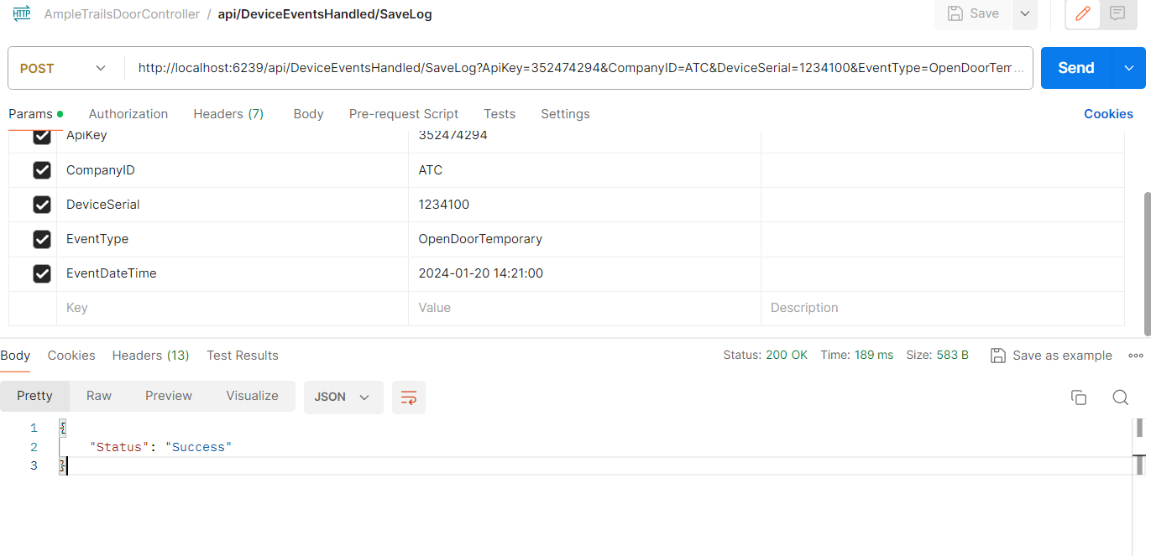

Update Status of Commands Completed
[POST]
Example:
http://localhost:6239/api/UpdateCommandStatus/UpdateRecord?ApiKey=352474294&CompanyID=ATC&DeviceSerial=1234100&CommandID=1
Parameters:
http://localhost:6239/api/UpdateCommandStatus/UpdateRecord?
ApiKey=352474294
CompanyID=ATC
DeviceSerial=1234100
CommandID=1
Response:
{"Status":"Success"}

Postman:
